Practical 4
Designing and configuring a network topology

Aim: Configure IP static routing
Theory:
- Static routing method is most trusted by a router.
- Static routing is not really a routing protocol.
- Static routes do not dynamically adapt to network changes, are not particularly scalable, and require manual updating to reflect changes.

Static routing has the following advantages
- There is no bandwidth usage between routers, which means you could possibly save money on WAN links.
- There is no overhead on the router CPU, which means you could possibly buy a cheaper router than you would use if you were using dynamic routing.
- It adds security because the administrator can choose to allow routing access to certain networks only.
Static routing has the following disadvantages
- Static routes don’t dynamically adapt to network change.
- If a network is added to the internetwork, the administrator has to add a route to it on all routers—by hand.
- It’s not feasible in large networks because maintaining it would be a full- time job in itself.
- With static routing, as your network grows, it can be difficult just keep adding static routes makes sure everybody can still get everything.
- The administrator must really understand the internetwork and how each router is connected in order to configure routes correctly.

There are two different styles to configure an “ip route” command:
- Using a next hop IP address
- Using an outgoing interface

Consider the following network topology

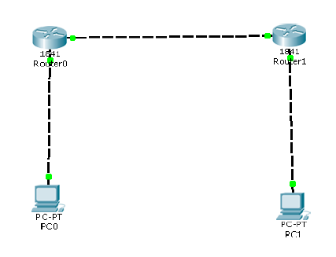

We use the following IP addresses for hosts and Routers

 | Interface | IP address | Subnet Mask | Gateway
PC0 |  | 10.0.0.2 | 255.0.0.0 | 10.0.0.1
PC1 |  | 30.0.0.2 | 255.0.0.0 | 30.0.0.1
Router 0 | FastEthernet 0/0 | 10.0.0.1 | 255.0.0.0
 | FastEthernet 0/1 | 20.0.0.1 | 255.0.0.0
Router 1 | FastEthernet 0/0 | 20.0.0.2 | 255.0.0.0
 | FastEthernet 0/1 | 30.0.0.1 | 255.0.0.0

We configure the given topology using Cisco Packet tracer as follows

Step 1: Configuring PC 0

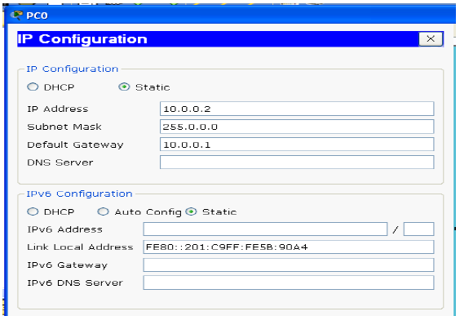

Step 2: Configuring PC 1

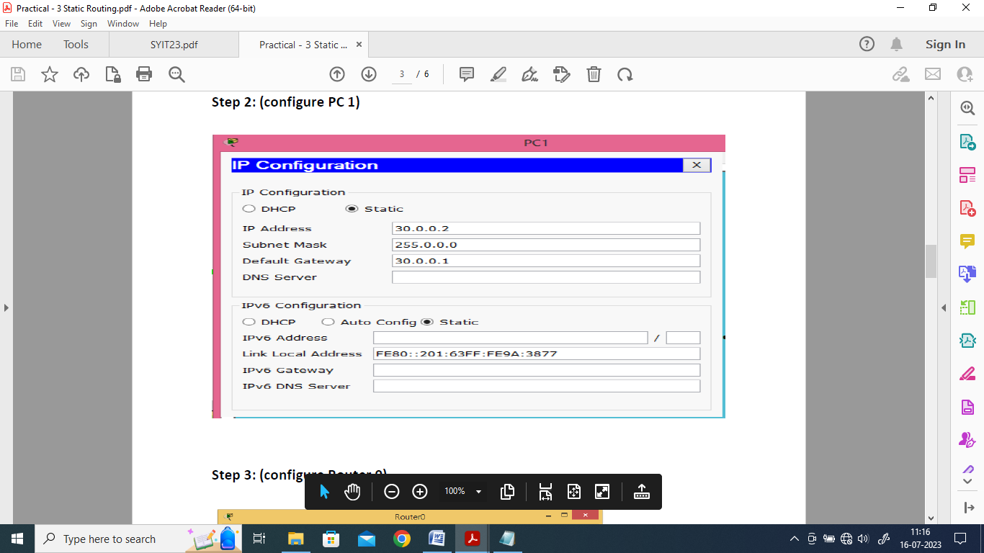

Step 3: Configuring Router 0
Interface: FastEthernet0/1
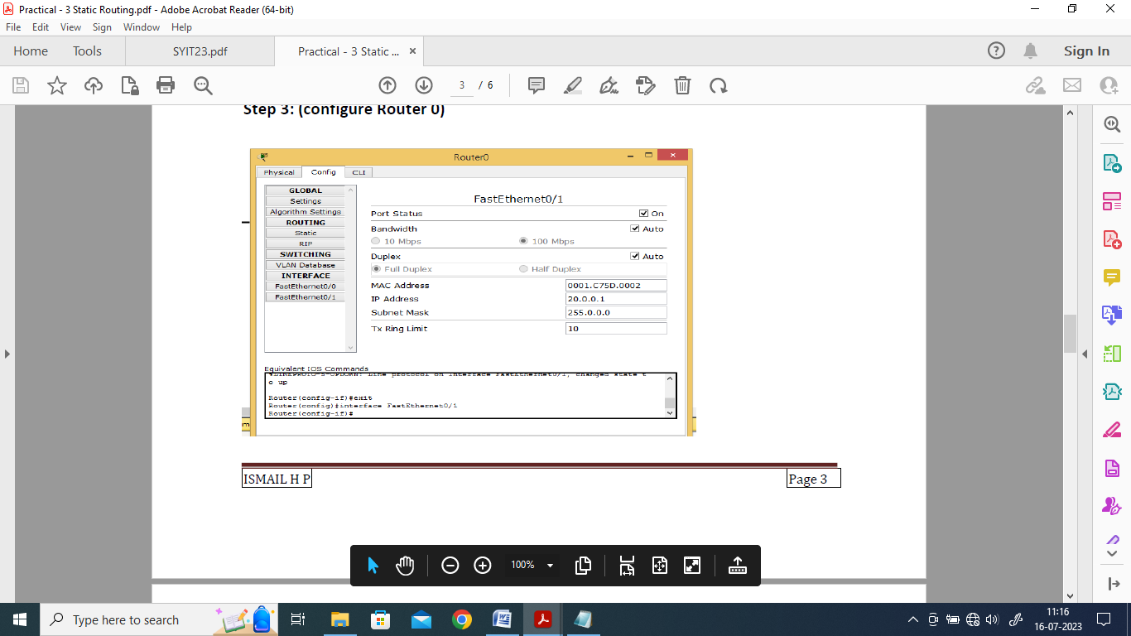

Interface: FastEthernet0/0
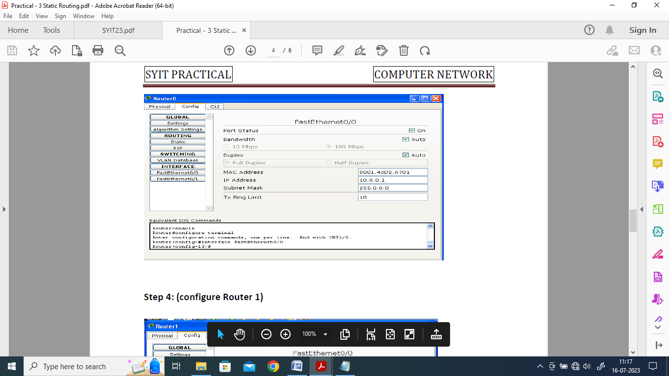

Step 4: Configure Router 1
Interface: FastEthernet0/0
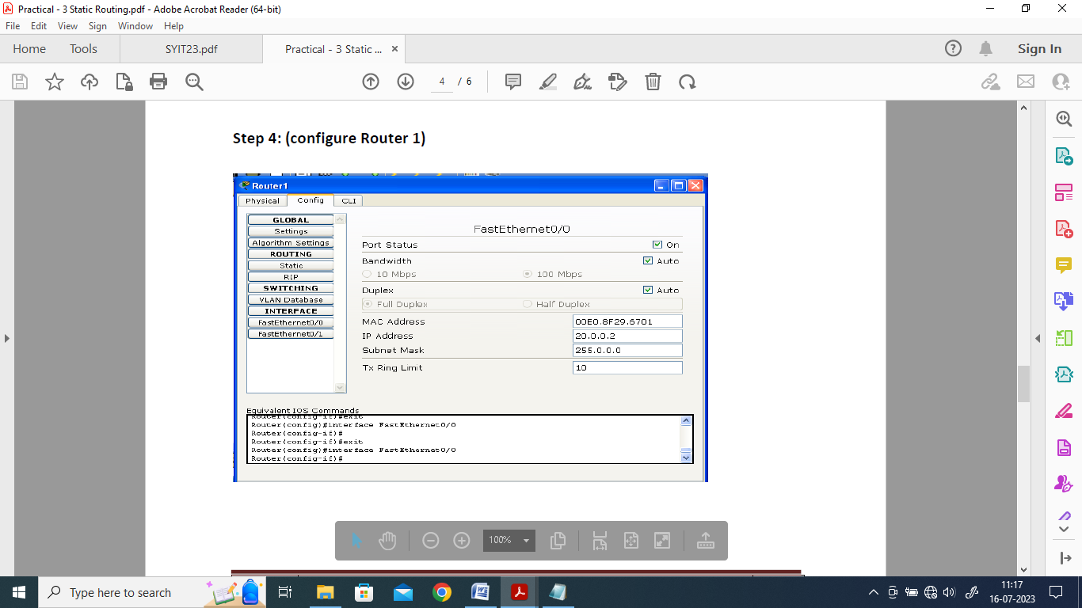

Interface: FastEthernet0/1

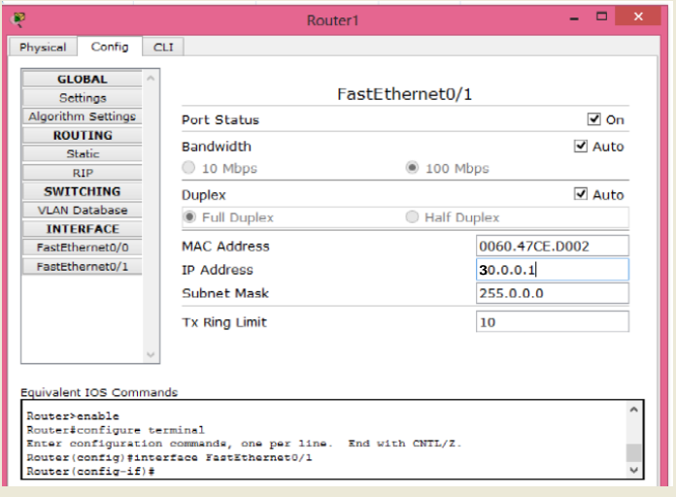

Step 5: Setting the Routing path in each Router through Static Routing
Step 5a) For Router 0
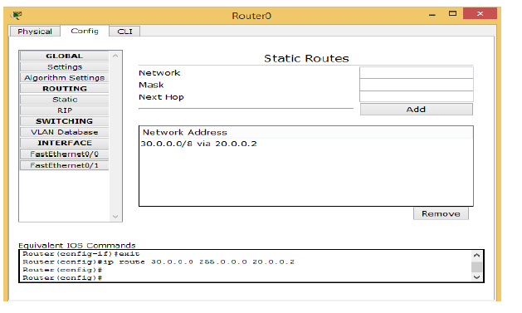

Step 5b) For Router 1
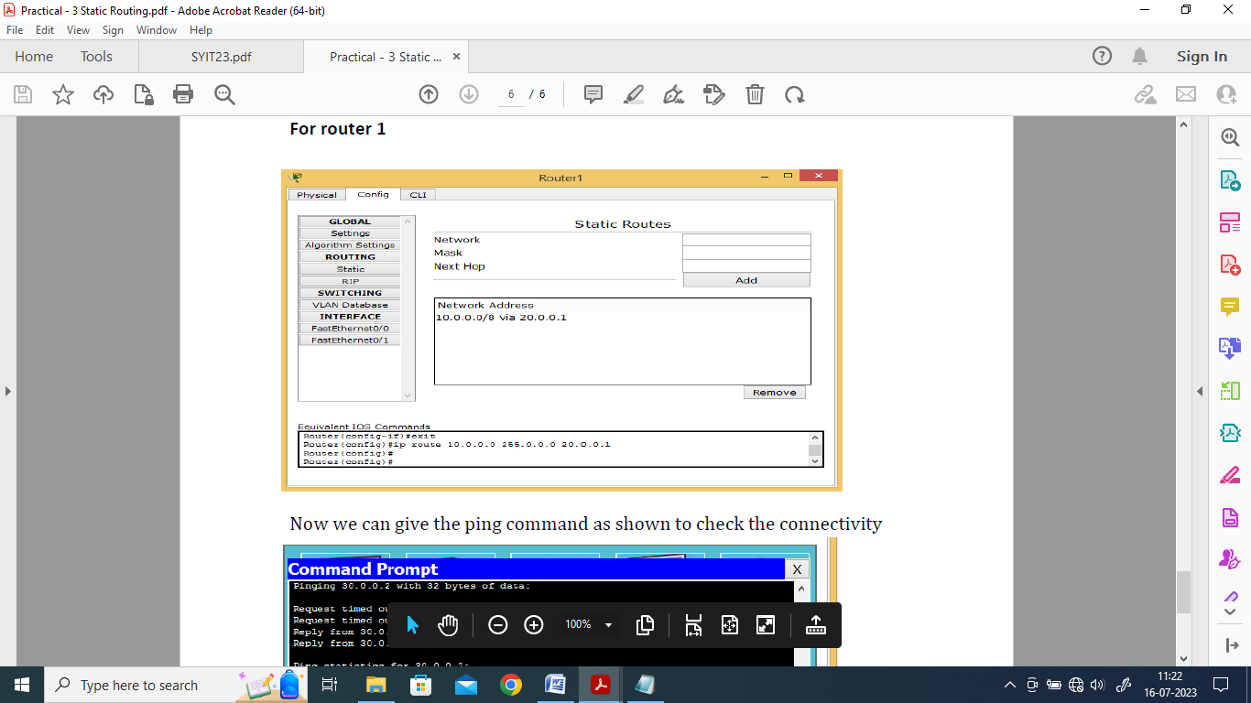

Step 6: Verifying the Connectivity using the Ping command

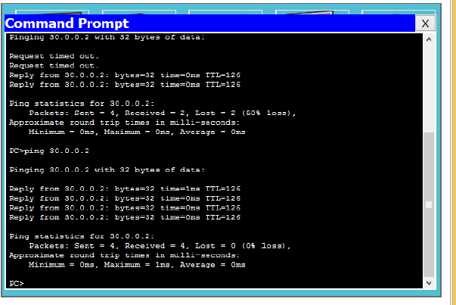

Hence static routing has been studied

For Video demonstration of the given Practical, scan the QR code | 

